**TABLE OF CONTENTS**

Declaration i

Certificate ii

Acknowledgement iii

Abstract iv

**1.Introduction** 1

1.1 Overview and motivation 1

1.2 Objective 1

Scope of project 1

**2. Institute Profile** 2

**3. Project Design** 3

3.1 Data Flow Diagrams 3

3.2 UML Diagrams 5

3.3 Database Design 7

**4. Implementation and User Interface** 10

**5. References and Bibliography** 18



**Department of Computer Engineering and Applications**

**GLA University, Mathura**

**17 km. Stone NH#2, Mathura-Delhi Road, P.O. – Chaumuhan,**

**Mathura – 281406**

**DECLARATION**

I hereby declare that the work which is being presented in the Training Project Report **“Enhancing Skills for Enterprise Scale Application Development”** in partial fulfillment of the requirements for Industrial Project on Airlines Reservation System is an authentic record of my own work carried under the supervision of **Dr. D.K. Yadav, Professor, MNNIT, Allahabad**.

Name of Candidate: Rishabh Singh

University Roll No.: 161500453

**CERTIFICATE**

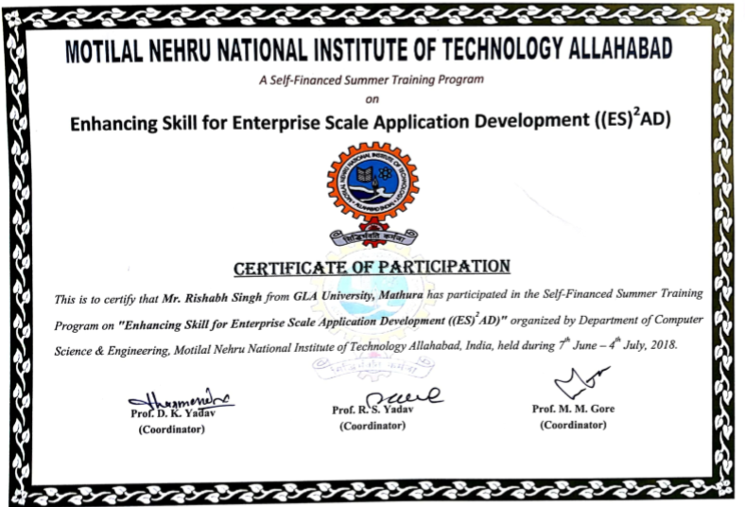

**ACKNOWLEDGEMENT**

We are extremely grateful to Dr. D.K. Yadav for his revered guidance and

encouragement, which led to the completion of this project till now. Without his

constant appraisal and efforts, this task would have been a mere dream. He was always

there to help us throughout this project.He provided us with all the necessary resources

and guidance during the project which helped us to complete the project successfully.

Finally we deem it a great pleasure to thank one and all who helped us directly or

indirectly in carrying out this project work. We are also thankful to our colleagues and

friends for their support. On a personal note , we owe everything to the almighty and

our parents . We would also like to thank our parents and other family members whose

constant support and motivation helped us to complete the project successfully .

**ABSTRACT**

Airline Reservation System is a computerized system used to store and retrieve information

and conduct transactions related to air travel. The system allows the airline passenger to

search for flights that are available between the two travel cities , namely the Source

and Destination for a particular departure and arrival dates . The system displays all the

flight’s details such as flight no, name, price, date and time of journey etc.

After search the system display list of available flights and allows passenger to choose a

particular flight. Then the system checks for the availability of seats on the flight . If the

seats are available then the system allows the passenger to book a seat . Otherwise it asks

the user to choose another flight.

To book a flight the system asks the customer to enter his details such as name, address,city, state, and credit card number and contact number. Then it check the validity of card and, book the flight and update the airline database and user database. The system also allows the customer to cancel his/her reservation, if any problem occurs.

The main purpose of this software is to reduce the manual errors involved in the airline reservation process and make it convenient for the customers to book the flights as when they require such that they can utilize this software to make reservations, or cancel a particular reservation.